Chapter 15, Problem 58.

Given that

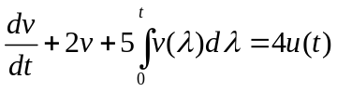

with v(0)= –1, determine v(t) for t>0.

